

Diploma in Aerospace System & Management

Final Year Project (EGK324) Report

Project Title:
Development of an electronic device for kitchen fire prevention (Phase 4) & Development of an innovative massage bed

Project Supervisor:
Seah Leng Wah
Project Student:
Tan Jia Hao (211496M)
Enable notifications so that the phone can receive notifications whenever which requirements it hit (e.g gas level too high)

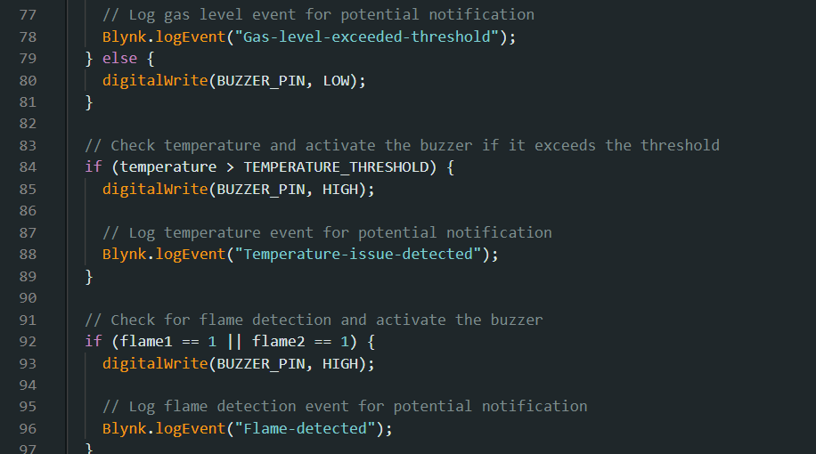
Example for the gas sensor, the code that is required is “Blynk.logEvent(“Gas-level-exceeded-threshold”);

Code & Codes Explanation
#define BLYNK_TEMPLATE_ID "TMPL6o33TOgKF"
#define BLYNK_TEMPLATE_NAME "Quickstart Template"
#define BLYNK_AUTH_TOKEN "sk8-yXxalIHrOE6HhOVWyuNu7tZHkrJi"
#define BLYNK_PRINT Serial

#include <WiFi.h>
#include <WiFiClient.h>
#include <BlynkSimpleEsp32.h>
#include <Wire.h>
#include <Adafruit_MLX90614.h>

char ssid[] = "Jiahao";
char pass[] = "cardes123";

// Define pin numbers for various sensors and actuators
#define FLAME_SENSOR_1_PIN 39
#define FLAME_SENSOR_2_PIN 36
#define MOTION_SENSOR_PIN 26
#define GAS_SENSOR_PIN 34
#define BUZZER_PIN 13 // Define your buzzer pin number
#define GAS_THRESHOLD 3500 // Set your gas threshold value
#define TEMPERATURE_THRESHOLD 35.0 // Set your temperature threshold value

Adafruit_MLX90614 mlx = Adafruit_MLX90614();
BlynkTimer timer;

void setup() {
Serial.begin(115200);

// Initialize pin modes for sensors and actuators
pinMode(FLAME_SENSOR_1_PIN, INPUT);
pinMode(FLAME_SENSOR_2_PIN, INPUT);
pinMode(MOTION_SENSOR_PIN, INPUT);
pinMode(BUZZER_PIN, OUTPUT);

// Initialize the MLX90614 sensor
mlx.begin();

// Connect to Blynk using Wi-Fi
Blynk.begin(BLYNK_AUTH_TOKEN, ssid, pass);

// Set up a timer to send sensor data to Blynk at regular intervals
timer.setInterval(1000L, sendSensorData);
}

void loop() {
// Run Blynk and timer events
Blynk.run();
timer.run();
}

void sendSensorData() {
// Read sensor values
int flame1 = digitalRead(FLAME_SENSOR_1_PIN);
int flame2 = digitalRead(FLAME_SENSOR_2_PIN);
int motion = digitalRead(MOTION_SENSOR_PIN);
int gasValue = analogRead(GAS_SENSOR_PIN);

// Invert flame sensor readings
flame1 = !flame1;
flame2 = !flame2;

// Read object temperature in Celsius
float temperature = mlx.readObjectTempC();

// Send sensor data to Blynk
Blynk.virtualWrite(V7, flame1); // Flame Sensor 1
Blynk.virtualWrite(V8, flame2); // Flame Sensor 2
Blynk.virtualWrite(V2, motion); // Motion Sensor
Blynk.virtualWrite(V5, gasValue); // Gas Sensor
Blynk.virtualWrite(V6, temperature); // Temperature Sensor

// Check gas level and activate the buzzer if it exceeds the threshold
if (gasValue > GAS_THRESHOLD) {
digitalWrite(BUZZER_PIN, HIGH);

// Log gas level event for potential notification
Blynk.logEvent("Gas-level-exceeded-threshold");
} else {
digitalWrite(BUZZER_PIN, LOW);
}

// Check temperature and activate the buzzer if it exceeds the threshold
if (temperature > TEMPERATURE_THRESHOLD) {
digitalWrite(BUZZER_PIN, HIGH);

// Log temperature event for potential notification
Blynk.logEvent("Temperature-issue-detected");
}

// Check for flame detection and activate the buzzer
if (flame1 == 1 || flame2 == 1) {
digitalWrite(BUZZER_PIN, HIGH);

// Log flame detection event for potential notification
Blynk.logEvent("Flame-detected");
}

// You can add more logic here to trigger additional actions based on sensor readings
}

Codes
// Blynk template information
#define BLYNK_TEMPLATE_ID "TMPL6CsmGhs8p"
#define BLYNK_TEMPLATE_NAME "Vibrator Testing"
#define BLYNK_AUTH_TOKEN "Im2fMtVY-5B9pCHmHzaMVYUBUbYM0qKG"
#define BLYNK_PRINT Serial

// Include necessary libraries
#include <WiFi.h>
#include <WiFiClient.h>
#include <BlynkSimpleEsp32.h>
#include <WiFiUdp.h>
#include <ArduinoOTA.h>

// Define GPIO pins for LEDs and Blynk virtual pins for sliders
#define LED1 23
#define LED2 22
#define LED3 21
#define VPIN_SLIDER_1 V0
#define VPIN_SLIDER_2 V1
#define VPIN_SLIDER_3 V2

// WiFi credentials
char ssid[] = "Jiahao";
char pass[] = "cardes123";

// Variables to store slider values
int slider1 = 0;
int slider2 = 0;
int slider3 = 0;

// Setup function
void setup()
{
Serial.begin(115200); // Initialize serial communication
Blynk.begin(BLYNK_AUTH_TOKEN, ssid, pass); // Initialize Blynk with authentication token and WiFi credentials
ArduinoOTA.begin(); // Initialize ArduinoOTA for over-the-air updates
}

// Blynk callback for slider V0
BLYNK_WRITE(VPIN_SLIDER_1)
{
slider1 = param.asInt(); // Get the slider value from Blynk
analogWrite(LED1, slider1);
Serial.print("V0 Slider value is: ");
Serial.println(slider1);
}

// Blynk callback for slider V1
BLYNK_WRITE(VPIN_SLIDER_2)
{
slider2 = param.asInt(); // Get the slider value from Blynk
analogWrite(LED2, slider2);
Serial.print("V1 Slider value is: ");
Serial.println(slider2);
}

// Blynk callback for slider V2
BLYNK_WRITE(VPIN_SLIDER_3)
{
slider3 = param.asInt(); // Get the slider value from Blynk
analogWrite(LED3, slider3);
Serial.print("V2 Slider value is: ");
Serial.println(slider3);
}

// Loop function
void loop()
{
Blynk.run(); // Run Blynk
ArduinoOTA.handle(); // Handle ArduinoOTA updates
}

